**Antique Small Pretty Gold Hanging Mirror**

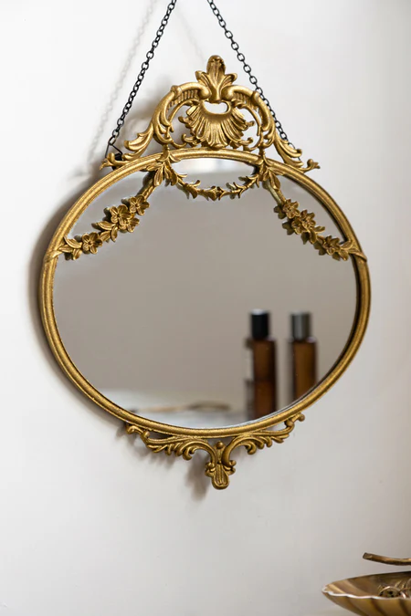The Antique Small Pretty Gold Hanging Mirror is a charming and elegant piece that adds a touch of luxury to any room. With its delicate, gold-toned frame and graceful design, this mirror exudes vintage appeal and sophistication. The small size makes it perfect for accentuating smaller spaces such as entryways, bathrooms, or cozy corners. Its intricate detailing and antique finish provide a timeless elegance, while the convenient hanging feature allows it to be easily displayed on any wall. This mirror serves not only as a functional reflection but also as a beautiful decorative element that enhances the overall aesthetic of your home.